All’s well that Ends Well

On 14thMarch2018 White Horse Theatre performed the play ”All’s Well that Ends Well” written by William Shakespeare.
There were four actors who played 5 characters. Bertram hasto marry Helena, but he doesn’t want to do this, because she’s only a servant. But she plays a smart trick together with another girl named Diana to make sure that she will be his real wife forever.
I have always liked the acting skills ofthe actors, so I wasn’t surprised, that they were as good as always. I really like how they use their equipment. It’s so handy and well planned and there are lots of great ideas in using the things.
They also involved the audience, this time it was a teacher, but I don’t know her name. But it was good fun!
Since I started to be interested in making costumes, I think that the costumes were great and really realistic for this century.
I didn’t like the storyline, because it was a bit boring and sometimes illogical, but all in all, it was a nice play with some ironic scenes.

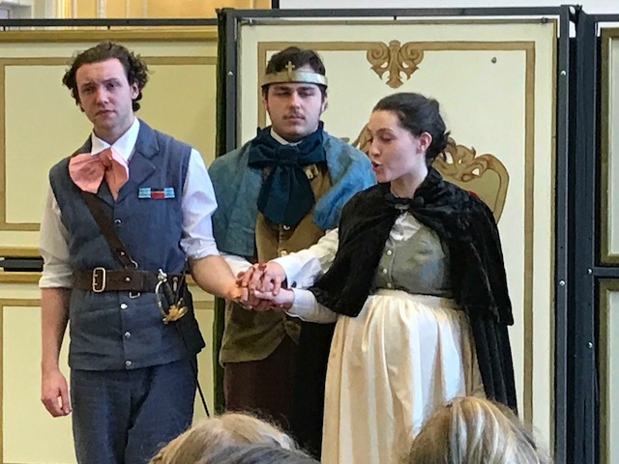
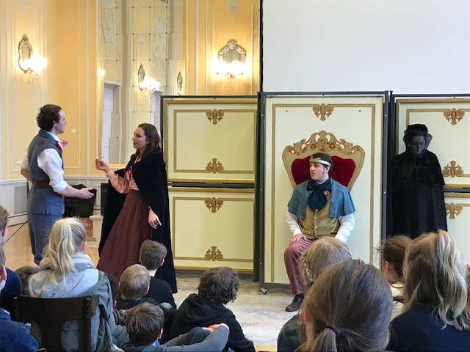
Emily Häntzschel, 8/2, Romain-Rolland-Gymnasium, Dresden

